Book

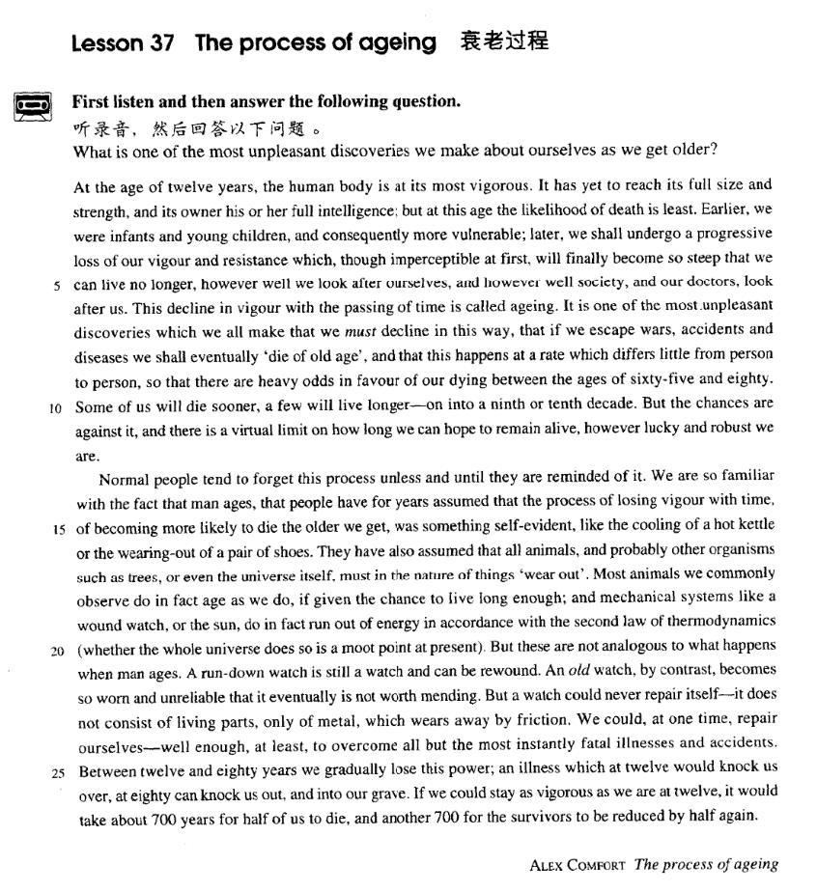

课文

At the age of 12 years, the human body is at its most vigorous.

人体在12岁时是生命力最旺盛的时期。

It has yet to reach its full size and strength, and its owner his or her full intelligence: but at this age the likelihood of death is least.

虽然这个时期人的身材、体力和智力还有待发展和完善，但在这个年龄死亡的可能性最小。

Earlier, we were infants and young children, and consequently more vulnerable;

再早一些，我们是幼儿和小孩子，身体较脆弱；

later, we shall undergo a progressive loss of our vigour and resistance which, though imperceptible at first will finally become so steep that we can live no longer,

再迟一些，我们就要经历生命力和抵抗力逐步衰退的过程。虽然这个过程起初难以觉察，

however well we look after ourselves, and however well society, and our doctors, look after us.

但最终会急转直下，不管我们怎样精心照料我们自己，不管社会和医生怎样对我们进行精心照顾，我们也无法再活下去了。

This decline in vigour with the passing of time is called ageing.

生命力随着时间的流失而衰退叫做衰老。

It is one of the most unpleasant discoveries which we all make that we must decline in this way, that if we escape wars, accidents and diseases we shall eventually 'die of old age', and that this happens at a rate which differs little from person to person, so that there are heavy odds in favour of our dying between the ages of 65 and 80.

人类发现的最不愉快的一个事实是：人必然会衰老。既使我们能避开战争、意外的事故和各种疾病，我们最终也会“老死”；衰老的速度在人与人之间相差甚微，我们最可能死亡的年龄在65至80岁之间，

Some of us will die sooner, a few will live longer -- on into a 9th or 10th decade.

有些人会死得早一些，少数人寿命会长一些 -- 活到八十几岁或九十几岁，

But the chances are against it, and there is a virtual limit on how long we can hope to remain alive, however lucky and robust we are.

但这种可能性很小。不管我们多么幸运，多么健壮，我们所希望的长寿实际上是有限度的。

Normal people tend to forget this process unless and until they are reminded of it.

衰老的过程，不经提起，正常人容易忘记；一经提醒，才会记起。

We are so familiar with the fact that man ages, that people have for years assumed that the process of losing vigour with time, of becoming more likely to die the older we get, was something self-evident like the cooling of a hot kettle or the wearing-out of a pair of shoes.

我们对人总是要衰老的现象并不陌生，多年来就已认识到。生命随着时间流失而丧失活力，人随着年龄的增长而接近死亡，这是不言而喻的，就像一壶热水迟早会凉不来，一双鞋渐渐会磨破一样。

They have also assumed that all animals, and probably other organisms such as trees, or even the universe itself, must in the nature of things 'wear out'.

人们不但认识到所有的动物，大概也认识到所有的有机物。如树木，甚至宇宙本身，从事物的本质上来说都会“磨损掉”。

Most animals we commonly observe do in fact age as we do, if given the chance to live long enough;

我们通常看到的大多数动物，即使能让它们活得足够长久的话，也会像我们一样衰老的。

and mechanical systems like a wound watch, or the sun, do in fact run out of energy in accordance with the second law of thermodynamics (whether the whole universe does so is a moot point at present).

像上紧发条的手表那样的机械装置，或太阳，也都会消耗完其能量（整个宇宙否如此，目前沿有争论）。

But these are not analogous to what happens when man ages.

不过，这些衰老的情况同人并不相似。

A run-down watch is still a watch and can be rewound. An old watch, by contrast, becomes so worn and unreliable that it eventually is not worth mending.

手表停了依然是只手表，还可以重上好发条。然而一只老掉牙的手表，磨损太厉害，老得一点儿不准了，最终不值得修理了。

But a watch could never repair itself -- it does not consist of living parts, only of metal, which wears away by friction.

但是，手表决不会自行修理，它不是由有生命的部件组成，而是由金属组成，而金属可以随着磨擦而磨损殆尽。

We could, at one time, repair ourselves -- well enough, at least, to overcome all but the most instantly fatal illnesses and accidents.

而我们人，在一定时间内是可以自行修复的，除了暴病死或意外事故外，至少足以克服一切疾病和事故。

Between 12 and 80 years we gradually lose this power;

在12岁至80岁之间，我们逐渐丧失这种能力。

an illness which at 12 would knock us over, at 80 can knock us out, and into our grave.

能使我们在12岁时病倒的疾病，到了80岁可能会使我们一厥不振而进入坟墓。

If we could stay as vigorous as we are at 12, it would take about 700 years for half of us to die, and another 700 for the survivors to be reduced by half again.

假如我们能保持12岁时的旺盛生命力，那么我们当中的一半人过700年才会死去，剩下的一半人再过700年，才会又减少一半。

词汇讲解

Lesson 37 The process of aging

likelihood ['laɪklihʊd]

n. 可能性

There is every likelihood that he will run for president next year. There is little likelihood that he will run for president next year. There is little likelihood of his attending the wedding.

There is every likelihood of the prophecy failing. in all likelihood = very likely

in all probability = very probably in all honesty = very honestly

in all frankness = very frankly

in all seriousness = very seriously

in all eagerness = very eagerly in all sincerity = very sincerely

History does not relate whether his friend accepted his medical help, but in all probability he did.

John Dewey has said in all seriousness that the part played by custom in shaping the behaviour of the individual, as against any way in which he can affect traditional custom, is as the proportion of the total vocabulary of his mother tongue against those words of his own baby talk that are taken up into the vernacular of his family.

Liu Bei made three personal calls at the thatched cottage to solicit Zhuge Liang’s help in all sincerity and eagerness.

Dear Edward: I’ve gone back and forth the last few days trying to decide whether or not I should even write this. In the end, I realized I would regret it if I didn’t. So, here goes. I know, the last time we saw each other, we weren’t exactly hitting the sweetest notes.

It certainly wasn’t the way I wanted our trip to end. I suppose I’m responsible, and for that I’m sorry. But in all honesty, if I had the chance, I'd do it again.

Good afternoon. My name is Edward Cole. I do not know what most people say on these occasions, because in all honesty I've tried to avoid them.

vulnerable ['vʌlnərəbl]

adj. 脆弱的，易受伤害的

vulnerable adj. weak or easy to hurt physically or mentally 脆弱的，易受伤害的

We should help the vulnerable groups in society. be vulnerable to sb. / sth.

Young birds are vulnerable to predators. The wound is vulnerable to infection.

Pesticides can cause an amphibian's skin to dry out.

Pesticides kill the insects that amphibians depend on for food.

Dissolved pesticides can easily enter amphibian's bodies.

Amphibians may eat plants that have been treated with pesticides.

Many pesticides that farmers applied to their crops are eventually washed away by the rain and end up in ponds or other bodies of water where amphibians live.

Amphibians are especially vulnerable to pesticides dissolved in the water because of their moist skins. Water can pass through an amphibian’s skin allowing toxins dissolved in the water to enter the amphibian’s body.

Many pesticides that farmers applied to their crops are eventually washed away by the rain and end up in ponds or other bodies of water where amphibians live. Amphibians are especially vulnerable to pesticides dissolved in the water because of their moist skins. Water can pass

through an amphibian’s skin allowing toxins dissolved in the water to enter the amphibian’s body.

Q: According to the speaker, why do pesticides pose a threat to amphibians?

Answer: (C) Dissolved pesticides can easily enter amphibian's bodies. be susceptible to sth.

Children are particularly susceptible to the disease. Some officials are susceptible to corruption.

paper tiger

US imperialism is a paper tiger. All reactionaries are paper tigers.

Achilles heel

Achilles: the hero of Homer’s Iliad, the son of Peleus and Thetis, the slayer of Hector

John’s Achilles heel is his vanity.

Official corruption remains the government’s Achilles heel. imperceptible

[7ɪmpə'septəbl]

adj. 感觉不到的，难以觉察的

imperceptible perceptible

tangible intangible

visible / in sight

invisible / out of sight

audible / within earshot

inaudible / out of earshot

John is too far away to hear.

John is out of money.

John hasn't left yet.

John doesn't hear well.

M: Hey, John! John!

W: Save your breath. He's out of earshot. Q: What does the woman mean?

Answer: (A) John is too far away to hear. ageing ['eɪdʒɪŋ]

n. & adj.

老化（的），老龄化（的）

aging / ageing

the process of aging the aging process the aging problem

China’s aging population graying / greying

the graying of the world the graying problem China’s graying population An idle youth, a needy age.

All that is in my mind when I meet a young person. He may be conceited, ill-mannered, presumptuous or fatuous, but I do not turn for protection to dreary clichés about respect of elders —as if mere age were a reason for respect.

I'll give you everything I can

I'll build your dreams with these two hands We'll hang some memories on the wall And when just the two of us are there

You won't have to ask if I still care 'Cause as time turns the page

My love won’t age at all

As we age, our skin becomes less elastic. She has aged well.

odds [ɒdz]

n. 可能性；困难，逆境

the odds are (that) …

The odds are (that) you're going to fail. the odds are in favor of …

the odds are against …

The odds are in favor of his winning. The odds are against his winning.

There are heavy odds in favor of his being married this year. There are overwhelming odds against an Argentinean victory. against (all) the odds

Against (all) the odds she achieved her dream of becoming a ballerina. beat / overcome the odds

fight / battle / struggle against the odds

If they had only had one more child, the fact would have passed unnoticed. They would have continued to struggle against economic odds and would have lived in obscurity.

fight / battle / struggle against the elements

Men accustomed to struggling for survival against the elements and Indians were bewildered by politicians, bankers and businessmen, and unhorsed by fences, laws and alien taboos.

thermodynamics [7θɜ:məʊdaɪ'næmɪks]

n. 热力学

thermodynamics n. a branch of physics dealing with the relations between

heat and other forms of energy 热力学“therm(o)” = heat thermometer thermos / Thermos

thermos / Thermos mug

thermal thermal energy

thermal spring thermal underwear

“dynam” = power dynamic dynamite dynamics

thermodynamics hydrodynamics

at most at least

at best at worst

at one’s + 形容词最高级处于某人最……的状态When are you at your best?

When are you at your worst?

When are you at your most effective? When are you at your most vulnerable? The garden is at its most beautiful in June.

Caesar was at his most powerful when he conquered Gaul. He was constantly on the move.

He is always on the go.

The patient is on the recovery.

The program is on the air at 7 o’clock. Crimes are on the rise.

The dog is on the alert. The workers are on strike. Today I’m on duty.

The nurse is on call. I’m here on business. I’m here on vacation. The car is under repair.

The castle is under attack.

The subject is under discussion. The matter is under consideration. You are under arrest.

The patient is under observation. The case is under investigation. The bridge is under construction. The building is under renovation.

It has yet to reach its full size and strength, and its owner (has yet to reach) his or her full intelligence; but *at this age* the likelihood of death is least. have yet to do 还没有……；有待于……

I have yet to make a decision.

The bank has yet to respond to our letter.

The Da Vinci Code, starring Tom Hanks, has yet to open next month.

… and we have only to turn to that extraordinary discovery of echo-location in bats to see a case in which the voice plays a strictly utilitarian role.

have only to do … to do …

只需……就可以……

You have only to press the button to call the nurse.

… and its owner (has yet to reach) his or her full intelligence.

Spiders are not insects, as many people think, nor even nearly related to them.

Spiders are not insects, as many people think, nor (are they) even nearly related to them.

Such inns as there were were generally dirty and flea-ridden; the food simply local cheese accompanied by bread often twelve months old, all washed down with coarse wine.

Such inns as there were were generally dirty and flea-ridden; the food (was) simply local cheese accompanied by bread often twelve months old, all washed down with coarse wine.

During these tests she was able to read a newspaper through an opaque screen and, stranger still, by moving her elbow over a child's game of

Lotto she was able to describe the figures and colours printed on it; and, in another instance, wearing stockings and slippers, to make out with her foot the outlines and colours of a picture hidden under a carpet.

During these tests she was able to read a newspaper through an opaque screen and, stranger still, by moving her elbow over a child's game of Lotto she was able to describe the figures and colours printed on it; and, in another instance, wearing stockings and slippers, (she was able) to make out with her foot the outlines and colours of a picture hidden under a carpet.

But, if this world is not merely a bad joke, life a vulgar flare amid the cool radiance of the stars, and existence an empty laugh braying across the mysteries; …

But, if this world is not merely a bad joke, life (is not merely) a vulgar flare amid the cool radiance of the stars, and existence (is not merely) an empty laugh braying across the mysteries; …

It is said that in England death is pressing, in Canada inevitable and in California optional. Small wonder. Americans’ life expectancy has nearly doubled over the past century. Failing hips can be replaced, clinical depression controlled, cataracts removed in a 30-minutes surgical procedure.

It is said that in England death is pressing, in Canada (death is) inevitable and in California (death is) optional. Small wonder. Americans’ life

expectancy has nearly doubled over the past century. Failing hips can be replaced, clinical depression (can be) controlled, cataracts (can be) removed in a 30-minutes surgical procedure.

Vegetables are best when they are fresh. We are busiest on Mondays.

… but at this age the possibilities of death are fewest.

*Earlier*, we were infants and young children, and consequently more vulnerable; *later*, we shall undergo a progressive loss of our vigour and resistance which, though imperceptible at first, will finally become so

steep *that we can live no longer, however well we look after ourselves, and however well society, and our doctors, look after us*.

Earlier, we were infants and young children, and (we were) consequently more vulnerable;

Although mankind has undergone no general improvement in intelligence or morality, ……

progressive progressive ideas a progressive party

progressive decline / reduction / increase / loss

One prominent symptom of the disease is progressive loss of memory.

… though (the loss is) imperceptible at first, …

It is one of the most unpleasant discoveries *which we all make* that we

must decline in this way, that *if we escape wars, accidents and diseases*

we shall eventually 'die of old age', and that this happens at a rate *which differs little from person to person, so that there are heavy odds in favour*

*of our dying between the ages of sixty-five and eighty*. decline v. deteriorate

His health has been declining / deteriorating progressively for several months.

decline an invitation

“ if ”引导让步状语从句1、= even if …

If he noticed the fact, he didn’t care.

… even their sagas, if they had any, are forgotten.

This result merely confirms earlier American and British studies: if there is any effect of noise upon mental health, it must be so small that present methods of psychiatric diagnosis cannot find it.

2、= although perhaps

Donald's essays are always interesting, if sometimes poorly written. She understood his meaning, if not his words, and took his advice. differ little

differ a little

differ greatly / significantly / enormously

vary from person to person

improve from day to day read sth. from cover to cover sell sth. from door to door

There are heavy / overwhelming odds in favor of / against … life expectancy

But the chances are against it, and there is a virtual limit on how long we can hope to remain alive, *however lucky and robust we are*.

The following day, however, the doctor consoled him by telling him that his chances of being able to leave hospital in time for new year celebrations were good.

As she is not rich, the chances that she will ever be able to afford such purchases are remote; but she is never sufficiently strong-minded to be able to stop the practice.

one’s chances of doing …

the chances that … are good / high.

are small / slight / remote.

造句：他赢得这次比赛的可能性很小。

His chances of winning the game are remote.

The chances that he will win the game are remote. there is a virtual limit / restriction on …

There is a virtual limit on how fast we can run.

There is a virtual restriction on the rate of economic growth in a specific country.

There are strict limits / restrictions on presidential power.

Normal people tend to forget this process unless and until they are reminded of it.

No credits will be awarded unless and until we receive official notification from the testing service.

Some people believe that a society has to place its overall success before the well-being of its members to achieve prosperity, whereas others believe that the only benchmark of the well-being of a society is the general welfare of all its people. Admittedly, a society should pursue its overall success, but from my perspective this goal will never be attained unless and until the well-being of all its individual citizens is properly respected.

We are so familiar with the fact that man ages, that people have for years assumed *that the process of losing vigour with time, of becoming more*

*likely to die the older we get, was something self-evident, like the cooling*

*of a hot kettle or the wearing-out of a pair of shoes*. I play the piano (the) better the more I practice.

The more I practice, the better I play the piano.

All truth passes through three stages. First, it is ridiculed. Second, it is violently opposed. Third, it is accepted as being self-evident.

— Arthur Schopenhauer Declaration of Independence

We hold these truths to be self-evident, that all men are created equal, that

they are endowed by the Creator with certain unalienable rights, that

among these are life, liberty, and the pursuit of happiness.

― Thomas Jefferson

… as a hot kettle cools down or a pair of shoes wears out.

They have also assumed that all animals, and probably other organisms

such as trees, or even the universe itself, must *in the nature of things*

'wear out'.

in the nature of things 必然，理所当然

It is in the nature of things that time wrecks all love. in the nature of … = similar to …

His speech is in the nature of an apology.

The statement is in the nature of an ultimatum. of a … nature 某一种类的

treaties of a political nature

questions of an academic nature dangers of the most perilous nature

Most animals we commonly observe do in fact age as we do, *if given the chance to live long enough*; and mechanical systems *like a wound watch,*

*or the sun*, do in fact run out of energy in accordance with the second law

of thermodynamics *(whether the whole universe does so is a moot point at present)*.

run out of …= use up = exhaust in accordance with …

in line with …

Pensions will be increased in line with inflation. in compliance with ..

In compliance with your wishes, we have withdrawn our suggestion. in (the) light of …

It has been said that everyone lives by selling something. In the light of this statement, teachers live by selling knowledge, philosophers by selling wisdom and priests by selling spiritual comfort.

Reading is thought to be a kind of conversation between the reader and the text. The reader puts questions, as it were, to the text and gets answers. In the light of these he puts further questions, and so on.

He explores such problem consciously, articulately, and frankly, first by

asking factual questions, then by asking moral questions, finally by

suggesting action which seems appropriate in the light of the factual and

moral information which he has obtained.

I am afraid that you have to alter your views in light of the tragic news that has just arrived.

(A) indifferent (B) distressing

(C) optimistic (D) pessimistic the first law of thermodynamics

the law of the conservation of energy a moot point

悬而未决的问题；有争议的问题

It’s a moot point whether building more roads reduces traffic congestion. be open to question / debate

……尚有争议

It’s open to question / debate whether the new government is any better than the old one.

But these are not analogous to what happens when man ages. be analogous to …

= be similar to …

Hypnotism is in a sense analogous to drunkenness.

His function is analogous to that of a judge, who must accept the

obligation of revealing in as obvious a manner as possible the course of

reasoning which led him to his decision.

be comparable to / with …

The threat it poses is comparable to / with smoking just one cigarette every year.

be akin to …

What he felt was more akin to pity than love.

be equivalent to …

The volcanic eruption had an explosive power equivalent to 20,000 tons of TNT.

An old watch, *by contrast*, becomes so worn and unreliable that it eventually is not worth mending.

by / in contrast

by / in comparison be worth doing

require / need / want *doing / to be done*

The watch requires / needs / wants *mending / to be mended*.

If it is not a question of resting the body, then perhaps it is the brain that needs *resting*?

But a watch could never repair itself—it does not consist of living parts, only of metal, which wears away by friction.

We could, *at one time*, repair ourselves—well enough, *at least*, to overcome all but the most instantly fatal illnesses and accidents.

all but adv. = almost

The research was all but forgotten. His left arm is all but useless.

Between twelve and eighty years we gradually lose this power; an illness which at twelve would knock us over, at eighty can knock us out, and into our grave.

knock sb. over

= knock sb. down

A car knocked him over.

He was knocked over by fever. knock sb. out

Tyson knocked out his opponent in round 2.

He was arguing with his girlfriend and she knocked him out with a frying pan.

The three drinks knocked him out.

have … get …

come down with…

catch … pick up …

Luke has measles. He must have picked it up at school. I hope I don’t catch it.

develop

develop lung cancer / diabetes

contract

contract pneumonia / AIDS

If we *could* stay as vigorous as we are at 12, it *would* take about 700 years for half of us *to die* and (it *would* take) another 700 for the survivors *to be reduced by half again*.

be reduced by …

be reduced by half / 20%

be reduced to … be reduced to 20%